**Data Analyst Job Analysis Report**

**1.Problem Statement**

As more companies look to hire data analysts, it’s important to understand where the jobs are, how much they pay, and what kind of companies are hiring. This helps job seekers, employers, and schools make better decisions. This report looks at the current data analyst job market to find useful trends.

**2. Objective (What Are We Trying to Do?)**

* To study and show job trends for data analyst roles.
* To find out which cities, industries, and company sizes offer the most jobs.
* To look at salary levels and company ratings by industry.
* To give helpful tips to job seekers, employers, and educators.

**3. Required Data**

To do this study, we need information like:

* Where the jobs are (location)
* Industry or sector (e.g., healthcare, finance)
* Size of the company
* Salary offered
* Company ratings
* Type of company (private, public, government, etc.)

**4. Tools Used**

* **Excel**  were used to make this dashboard.
* **Charts** like bar graphs, pie charts, and line graphs helped show the data clearly.

**5. Key insights**

**Top Job Locations**

* The most job openings are in **Mountain View, CA**.
* Other cities with many jobs: Ridley Park (PA), Deerfield (IL), Los Angeles, Seattle, and Union City.

**Salaries by Industry**

* **Best-paying industries**:
  + Biotech & Pharmaceuticals
  + Gas, Energy & Utilities
  + Aerospace & Defense
* **Lower-paying industries**:
  + Travel & Tourism
  + Restaurants and Food Services

**Company Ratings by Industry**

* Most companies have ratings between **3.0 and 4.0 out of 5**.
* Biotech and Construction have slightly better ratings.
* Some companies have very low or missing ratings.

**Salaries by Company Size**

* Companies with **501 to 1000 employees** pay the most (around **$93,000**).
* Very small or very large companies tend to pay a little less.

**Jobs by Company Type**

* Most jobs are from **private companies**.
* **Public companies** also offer many jobs.
* **Government, universities, and franchises** offer fewer jobs.

**Top-Rated Companies**

* **Five companies** have perfect **5-star ratings**.
* These include consulting, pharmaceutical, and finance companies.

**6. Recommendations**

**For Job Seekers:**

* Look for jobs in **Mountain View, CA** and in well-paying industries like **Biotech and Energy**.
* Medium-sized companies (501–1000 employees) often pay more.
* Apply to companies with higher ratings.

**For Employers:**

* Offer competitive salaries to match top industries.
* Work on improving company ratings by taking care of employees.
* Highlight strengths of medium-sized companies during hiring.

**For Educators and Policymakers:**

* Focus training programs on high-paying industries.
* Partner with top-rated companies to help students get jobs or internships.

**7. Result**

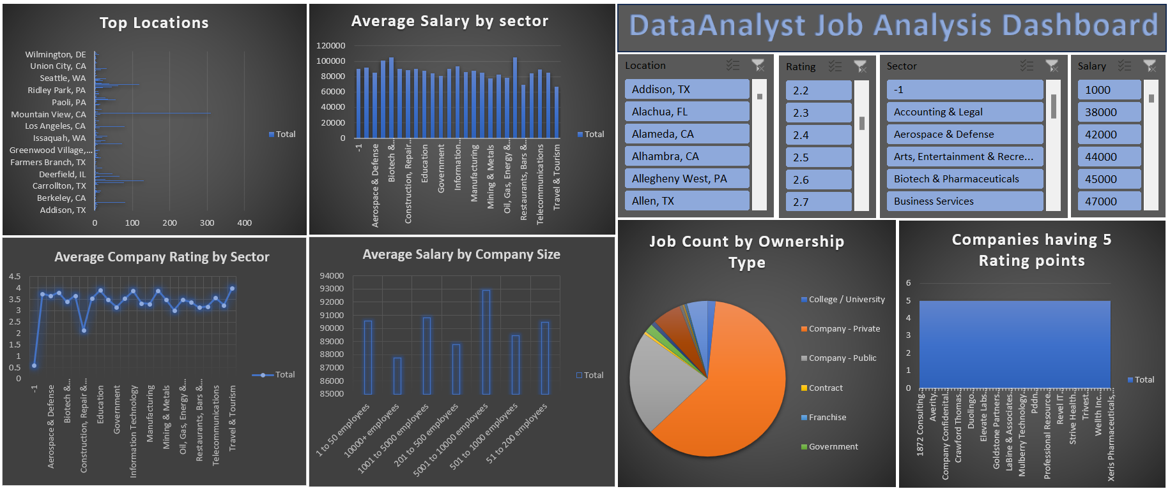

**8. Conclusion**

This dashboard gives a clear picture of the current data analyst job market. It shows where the jobs are, which industries pay well, and what kind of companies are hiring. This information can help job seekers plan their careers, help companies improve their hiring, and help schools design better programs. Keeping this data updated will make future decisions even better.

Overall, the dashboard is a helpful tool that supports better decision-making for everyone involved in the data analyst job market. It helps job seekers find the right jobs, helps companies hire more effectively, and guides people in planning their careers more wisely.